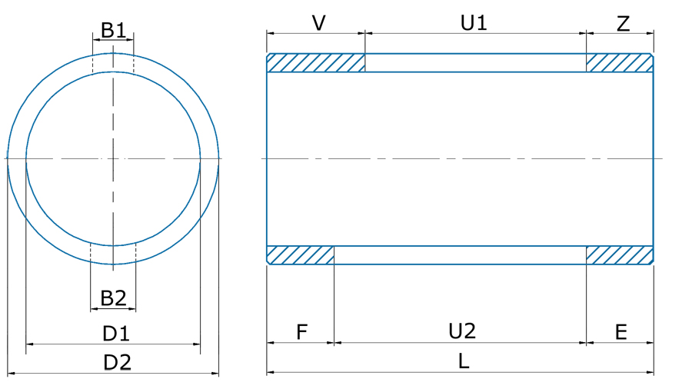

Размеры (мм)

|  |  |  |  |  |  |  |  |  |  |  |
| --- | --- | --- | --- | --- | --- | --- | --- | --- | --- | --- |
| L | ØD1 | ØD2 | B1 | U1 | V | Z | B2 | U2 | F | E |
|  |  |  |  |  |  |  |  |  |  |  |