Опросный лист

Для заказа зубчатой муфты SNL

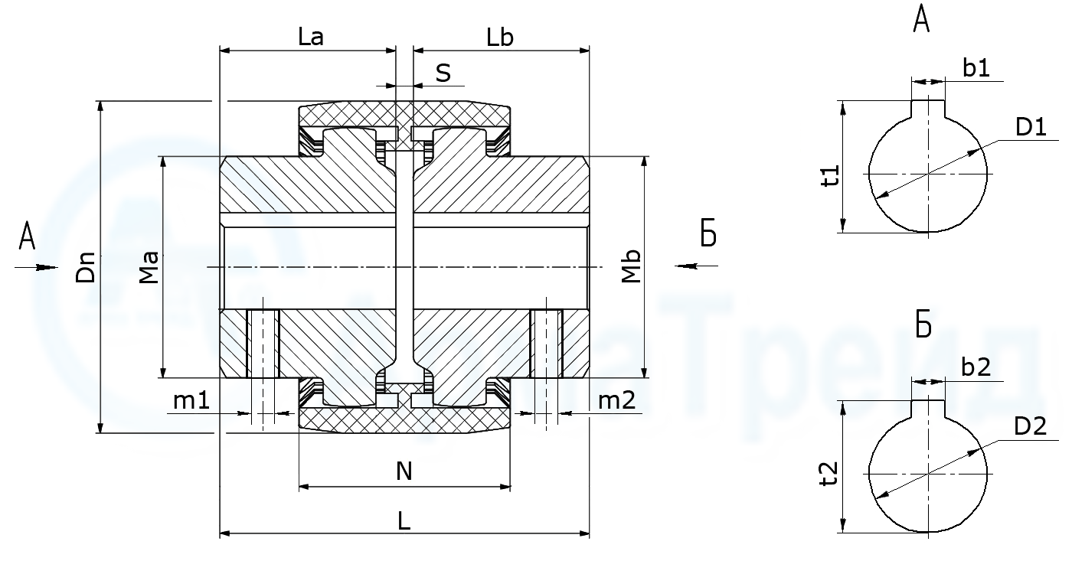

|  |  |  |  |  |  |
| --- | --- | --- | --- | --- | --- |
| ØD1 H9 | b1 | t1 | ØD2 H9 | b2 | t2 |
|  |  |  |  |  |  |

|  |  |  |  |  |  |  |  |  |  |
| --- | --- | --- | --- | --- | --- | --- | --- | --- | --- |
| ØMa | ØMb | m1 | m2 | La | Lb | L | S | N | ØDn |
|  |  |  |  |  |  |  |  |  |  |