Опросный лист

Для заказа кулачковой муфты ATESC тип B

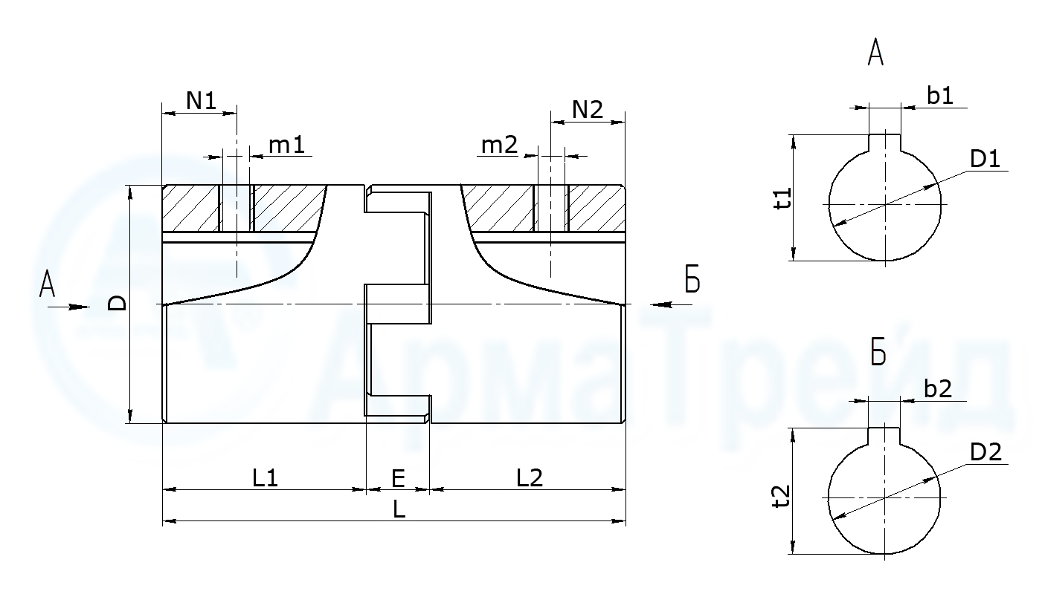

|  |  |  |  |  |  |
| --- | --- | --- | --- | --- | --- |
| ØD1 H9 | b1 | t1 | ØD2 H9 | b2 | t2 |
|  |  |  |  |  |  |

|  |  |  |  |  |  |  |  |  |
| --- | --- | --- | --- | --- | --- | --- | --- | --- |
| ØD | E | L | m1 | N1 | L1 | m2 | N2 | L2 |
|  |  |  |  |  |  |  |  |  |